A Review on IoT based Smart Agriculture

Name:- Neerendra Tripathi,

Pursuing Bachelor’s in Technology in Computer Science(IOT)

# 

# E-mail- neerendra0009@gmail.com

**Abstract**: Agriculture plays vital role in the development of agricultural country. In India about 70% of population depends upon farming and one third of the nation’s capital comes from farming. Issues concerning agriculture have been always hindering the development of the country. The only solution to this problem is smart agriculture by modernizing the current traditional methods of agriculture. Hence the project aims at making agriculture smart using automation and IoT technologies. The highlighting features of this project includes Arduino to perform tasks like spraying, moisture sensing,keeping vigilance, etc. Secondly it includes smart irrigation with smart control and intelligent decision making based on accurate real time field data. Thirdly, smart warehouse management which includes temperature maintenance, humidity maintenance.

**Keywords**: IoT, Soil Moisture Sensor,Microcontroller.

# INTRODUCTION

Agriculture is considered as the basis of life for the human species as it is the main source of food grains and other raw materials. It plays vital role in the growth of country’s economy. It also provides large ample employment opportunities to the people. Growth in agricultural sector is necessary for the development of economic condition of the country. Unfortunately, many farmers still use the traditional methods of farming which results in low yielding of crops and fruits. But wherever automation had been implemented and human beings had been replaced by automatic machineries, the yield has been improved. Hence there is need to implement modern science and technology in the agriculture sector for increasing the yield. Most of the papers signifies the use of wireless sensor network which collects the data from different types of sensors and then send it to main server using wireless protocol. The collected data provides the information about different environmental factors which in turns helps to monitor the system. Monitoring environmental factors is not enough and complete solution to improve the yield of the crops. There are number of other factors that affect the productivity to great extent. These factors include attack of insects and pests which can be controlled by spraying the crop with proper insecticide and pesticides. Secondly, attack of wild animals and birds when the crop grows up. There is also possibility of thefts when crop is at the stage of harvesting. Even after harvesting, farmers also face problems in storage of harvested crop. So, in order to provide solutions to all such problems, it is necessary to develop integrated system which will take care of all factors affecting the productivity in every stages like; cultivation, harvesting and post harvesting storage. This paper therefore proposes a system which is useful in monitoring the field data as well as controlling the field operations which provides the flexibility. The paper aims at making agriculture smart using automation and IoT technologies. The highlighting features of this paper is provide water to the agriculture field.

# LITERATURE REVIEW

The newer scenario of decreasing water tables, drying up of rivers and tanks, unpredictable environment present an urgent need of proper utilization of water. To cope up with this use of temperature and moisture sensor at suitable locations for monitoring of crops is implemented in[1].

An algorithm developed with threshold values of temperature and soil moisture can be programmed into a microcontroller-based gateway to control water quantity[2].

After the research in the agricultural field, researchers found that the yield of agriculture is decreasing day by day. However, use of technology in the field of agriculture plays important role in increasing the production as well as in reducing the extra man power efforts. Some of the research attempts are done for betterment of farmers which provides the systems that use technologies helpful for increasing the agricultural yield. V. R. Balaji and M. Sudha (2016) proposed a paper in which the system derives power from sunlight though photo-voltaic cells .This system doesn’t depend on electricity. The soil moisture sensor has been used and based on the sensed values PIC microcontroller is used to ON/OFF the motor pump. Weather forecasting is not included in this system [3].

R.Subalakshmi (2016) proposed a paper to make irrigation system simpler, the complexities involved in irrigation is tackled with automation system using microcontroller and GSM. Based on the sensed values from soil moisture, temperature and humidity sensors, the GSM sends message to the farmer when these parameters exceed the threshold value set in the program. The nutrient content in the soil is not determined by this system [4].

# ARCHITECTURE OF THE SYSTEM

# C:\Users\NIRENDRA TRIPATHI\Desktop\Smart-Irrigation-System-using-IoT.jpg

#### III(i) **Arduino UNO Board**

The Arduino UNO is one of the most used microcontrollers in the industry. It is very easy to handle, convenient, and use. The coding of this microcontroller is very simple. The program of this microcontroller is considered as unstable due to the flash memory technology. The applications of this microcontroller involve a wide range of applications like security, home appliances, remote sensors, and industrial automation. This microcontroller has the ability to be joined on the internet and perform as a server too.

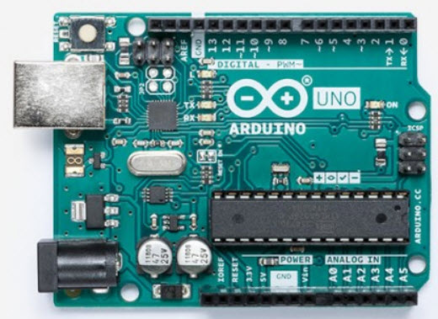

#### III(ii) **Soil Moisture Sensor**

Soil moisture sensor is [one kind of sensor](https://www.elprocus.com/types-of-sensors-with-circuits/) used to detect the soil moisture content. This sensor has two outputs like the analog output as well as the digital output.

The digital o/p is permanent and the analog o/p threshold can be changed. The working principle of soil moisture sensor is open & short circuit concept. Here the LED gives an indication when the output is high or low

When the condition of the soil is dried up, the flow of current will not flow through it. So it works like an open circuit. Therefore the o/p will be maximized. When the soil condition is soaked, the flow of current pass from one terminal to the other. So it works like a closed circuit. Therefore the o/p will be zero.

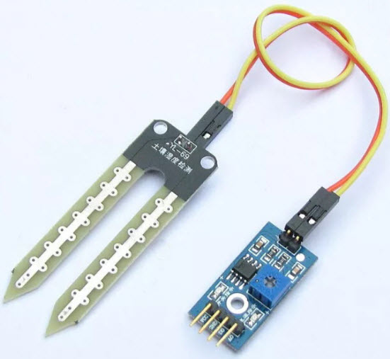

### IV.Working with Smart Irrigation System using IoT

In the agriculture field, sensors are used like soil moisture. The information received from the sensors is sent to the Database folder through the Android device. In the control section, the system is activated using the application, this is finished using the ON/OFF buttons in the application. Also, this system is automatically activated when the soil moisture is low, the pump is switched ON based on the moisture content.

The application has a feature like taking some time from the user and water the agriculture field when the time comes. In this system, there is a switch used to turn off the water supply if the system fails. Other parameters such as the moisture sensor demonstrate the threshold price and the level of water in the soil.

Smart Irrigation System using IoT

Further, this project can be enhanced by designing this system for large acres of soil. Also, this project can be incorporated to make sure the value of the soil and the expansion of harvest in each soil. The microcontroller and sensors are successfully interfaced and wireless communication is attained between a variety of nodes.

Also, further this proposed system can be enhanced by adding up machine learning algorithms, which are capable to study and recognize the necessities of the crop, this would aid the agriculture field to be an automatic system. The inspections and outcomes tell us that this result can be executed for a lessening of water loss and decrease the manpower necessary for a field.

From the above information, finally, we can conclude that the hardware components of this system interfaces with all the sensors. The system is powered by a power source, and the system has been checked for watering an agriculture field. If you have any queries regarding in implementing irrigation projects, please give your feedback by commenting in the comment section below. Here is a question for you, what is the function of IOT(Internet of Things)?

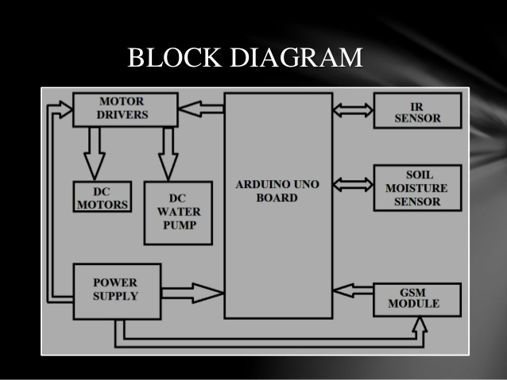

# REFERENCES

1. S. R. Nandurkar, V. R. Thool, R. C. Thool, “Design and

Development of Precision Agriculture System Using Wireless Sensor Network”, IEEE International Conference on

Automation, Control, Energy and Systems (ACES), 2014

1. JoaquínGutiérrez, Juan Francisco Villa-Medina, Alejandra

Nieto-Garibay, and Miguel Ángel Porta-Gándara,

“Automated Irrigation System Using a Wireless Sensor

Network and GPRS Module”,IEEE TRANSACTIONS ON

INSTRUMENTATION AND MEASUREMENT, 0018-9456,2013

1. Dr. V .Vidya Devi,G. Meena Kumari, “Real- Time Automation and

Monitoring System for Modernized Agriculture” ,International

Journal of Review and Research in Applied Sciences and Engineering (IJRRASE) Vol3 No.1. PP 7-12, 2013

1. Y. Kim, R. Evans and W. Iversen, “Remote Sensing and Control of an Irrigation System Using a Distributed Wireless Sensor Network”, IEEE Transactions on Instrumentation and

Measurement, pp. 1379–1387, 2008.

1. Q. Wang, A. Terzis and A. Szalay, “A Novel Soil Measuring

Wireless Sensor Network”, IEEE Transactions on Instrumentation and Measurement, pp. 412–415, 2010

1. Yoo, S.; Kim, J.; Kim, T.; Ahn, S.; Sung, J.; Kim, D. A2S: Automated agriculture system based on WSN. In ISCE 2007. IEEE International Symposium on Consumer Electronics, 2007, Irving,TX, USA, 2007
2. Arampatzis, T.; Lygeros, J.; Manesis, S. A survey of applications of wireless sensors and Wireless Sensor Networks. In 2005 IEEE International Symposium on Intelligent Control & 13th Mediterranean Conference on Control and Automation. Limassol, Cyprus, 2005, 1-2, 719-724
3. Orazio Mirabella and Michele Brischetto, 2011. “A Hybrid Wired/Wireless Networking Infrastructure for Greenhouse Management”, IEEE transactions on instrumentation and measurement, vol. 60, no. 2, pp 398-407.
4. N. Kotamaki and S. Thessler and J. Koskiaho and A. O. Hannukkala and H. Huitu and T. Huttula and J. Havento and M.